NOAA Records script
This script used the three digit WFO identifier, to retrieve the Normal high and low temperature, and Record high and low temperature for that location. The script will only work for the main WFO offices located on this site: https://w2.weather.gov/climate/ . So for my website, I got lucky that there is a WFO office right in my city. (BIS) This script assumes you are using the Saratoga scripts and you are adding the data to your ajaxdashboard PHP file. However this PHP file could be added to any PHP page.
- First download the noaarec.txt file from my site. https://www.bismarckweather.net/noaarec.txt
- Rename the file to noaarec.php.
- Find your WFO from the site https://w2.weather.gov/climate/ Once you click on your region, you’ll notice the web address at the top will read https://www.weather.gov/wrh/Climate?wfo=bis indicating that my site WFO is BIS.
- Edit the noaarec.php file. Enter in your three character WFO office in the wfo and sid lines.
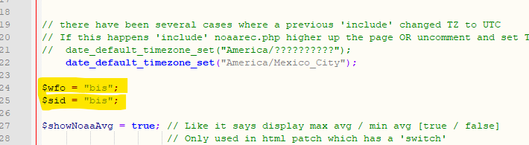
- Edit your ajaxdashboard.php file.
- At the top, you’ll need an include statement to add the data to your page.
  - Just below the “$ADBversion = 'ajax-dashboard.php - Version 1.34 - 03-Apr-2023 - Multilingual';” section, add the following line
  - include_once("noaarec.php");
- It should appear like this:
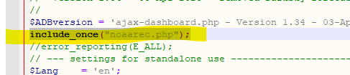

- If you are running the stock ajaxdashboard, scroll down to about line 1055. There will be a section relating to “end $haveSolar”. Below that you will be adding a table. If you have the alternate dashboard, you will still have this section. It’ll be further down than line 1055.
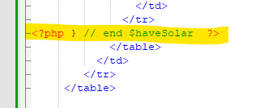
- Next add in the table to include the data being pulled from the noaarec.php file.
<table width="630" border="0" cellpadding="0" cellspacing="0" style = "font-weight: normal";>
<th style="text-align:center" colspan="2">National Weather Service History</th>
<tr style="text-align:center">
<td>Normal High: &nbsp;<?php echo $thisDayMaxAvg; ?>&deg;F</td>
<td>Normal Low: &nbsp;<?php echo $thisDayMinAvg; ?>&deg;F</td>
</tr>
<tr style="text-align:center">
<td>Record High: &nbsp;<?php echo $thisDayMax; ?>&deg;F &nbsp;<?php echo $thisDayMaxYear; ?></td>
<td>Record Low: &nbsp;<?php echo $thisDayMin; ?>&deg;F &nbsp;<?php echo $thisDayMinYear; ?></td>
</tr>
</table>

- That’s all that’s needed. Upload the 2 updated PHP files to your site. It’ll add this section in below your live weather, and above your forecast. (Ignore the rain data. That’s in another script that I will be documenting)
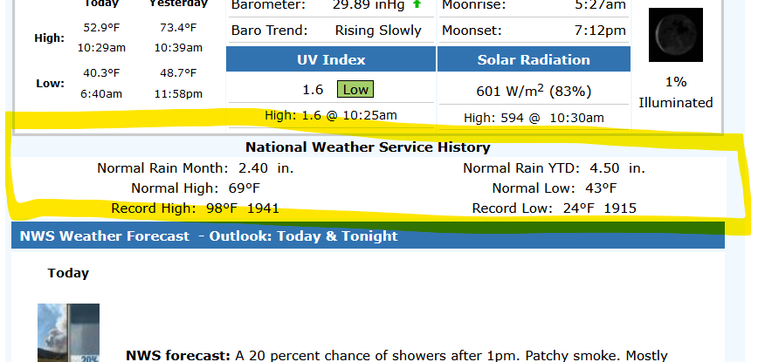
- The noaarec.php file will get today’s date, then query the WFO office for the temperature data and input it to the screen.

I can’t take credit for the creation of this file. I’m just trying to document how to set it up. The original creator is “the beteljuice” from the WXForum.net site.
Here is the full posts on the file:
https://www.wxforum.net/index.php?topic=37220.0

You can also run the noaarec.php file in debug mode. It’ll show the raw data being pulled from the WFO site.

https://www.bismarckweather.net/noaarec.php?noaabug

