Random Image on Header
I have found a script that will pull a random image from a specified folder, and display that image in your header section. I like to rotate my images for the seasons and put in special holiday pictures as well. Once setup, you can add and remove images from the folder to keep your banner pictures fresh and new. While my example is utilizing the header.php file from the Saratoga scripts, it could be applied to any PHP page.
- You will need to download your header.php file.
- Edit your header.php file in Notepad, or Notepad ++.
- Near the top, you will find the “require_once("Settings.php");” and “require_once("common.php");”. Below that, add a line “$dir_path = "/bwimages";”
  - For my example, I’m using a folder name of bwimages in the root. This is because my site is BismarckWeather.net. But you could choose a different folder name such as bannerimages if you wish. Just rename the bwimages folder name to one of your choosing.
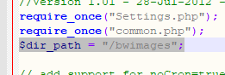
- Just below the lines shown below, you will paste in a new section of PHP code from step 5 below.
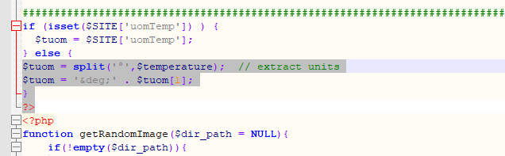
- This is the full PHP code to add below the “?>”. This is the random file selector. You’ll want to edit your ALT=”BismarckWeather.net” section to give your site name to the picture.
<?php
function getRandomImage($dir_path = NULL){
if(!empty($dir_path)){
$files = scandir($dir_path);
$count = count($files);
if($count > 2){
$index = rand(2, ($count-1));
$filename = $files[$index];
return '<img src="'.$dir_path."/".$filename.'" alt="Bismarckweather.net">';
} else {
return "The directory is empty!";
}
} else {
return "Please enter valid path to image directory!";
}
}
?>
- Further down in your header.php file, you will find a line like below.
  - <h1 class="headerTitle" align="center">
- Just below that line, add in this last section of PHP code.
<?php
echo getRandomImage("bwimages");
?>

- It should look like this:
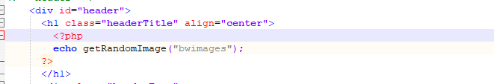
- From there, you upload whatever image files you wish into the “bwimages” folder. Personally, all of my banner files are of the same size and I put my site name on the pictures. But once you have the images created, just upload new ones and delete old ones from the folder.
- Here is a screen shot of the files I had in my folder at the time of writing this manual.
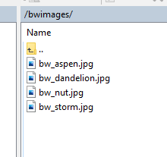
- Every time the page is reloaded, it will randomly pick one of the files in the folder to be your banner image. I use JPG files, but I believe any image file should work.

And that’s it!

